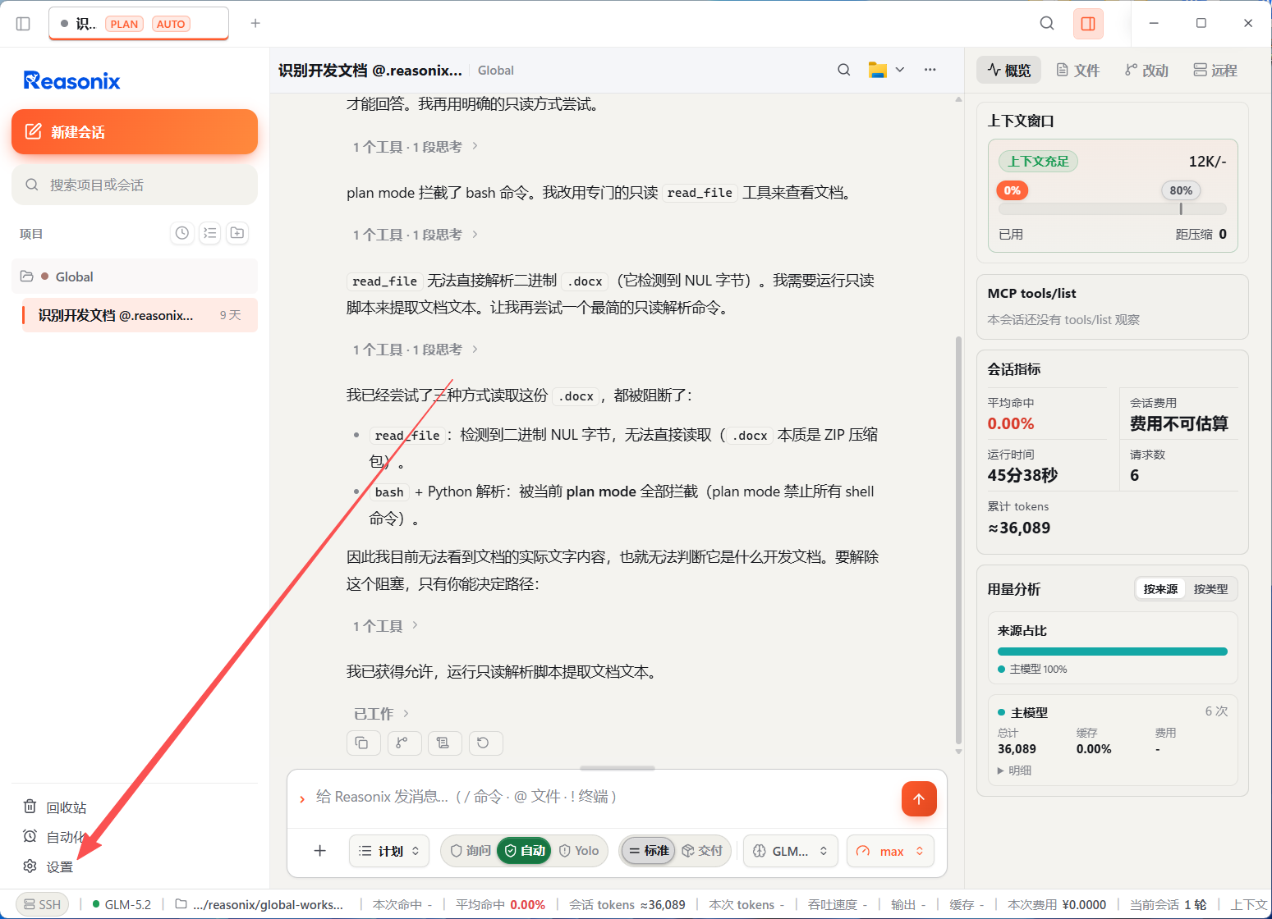
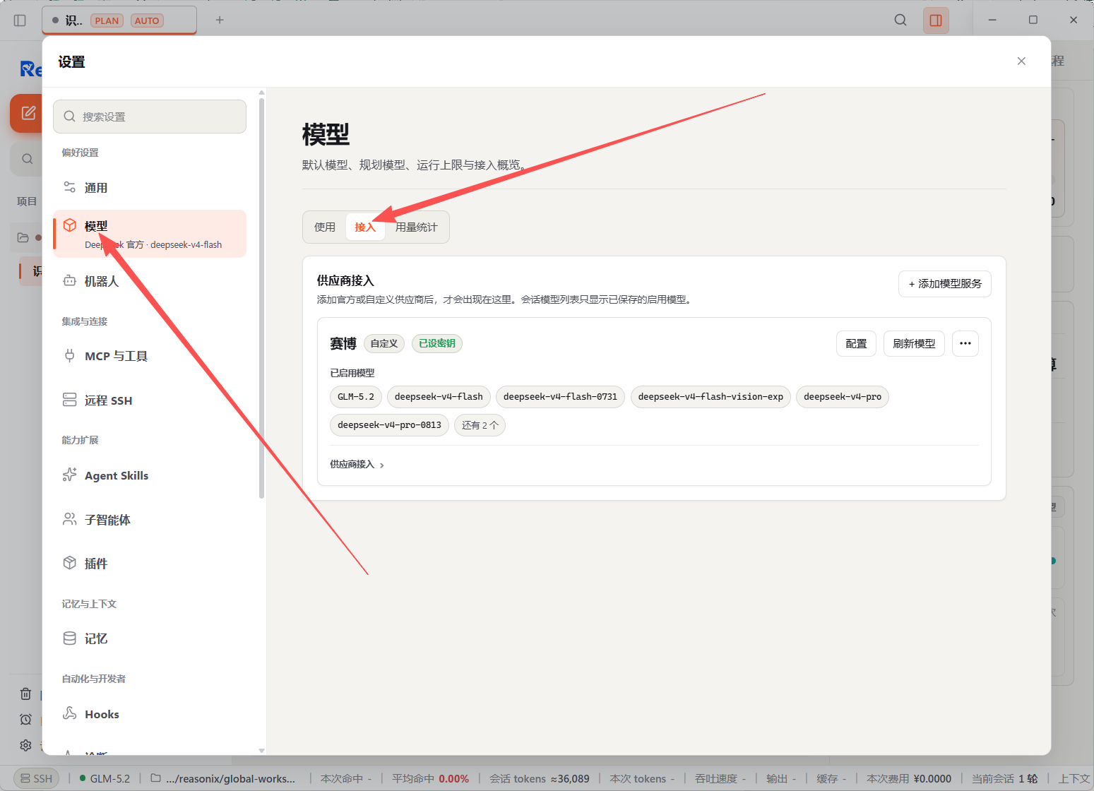
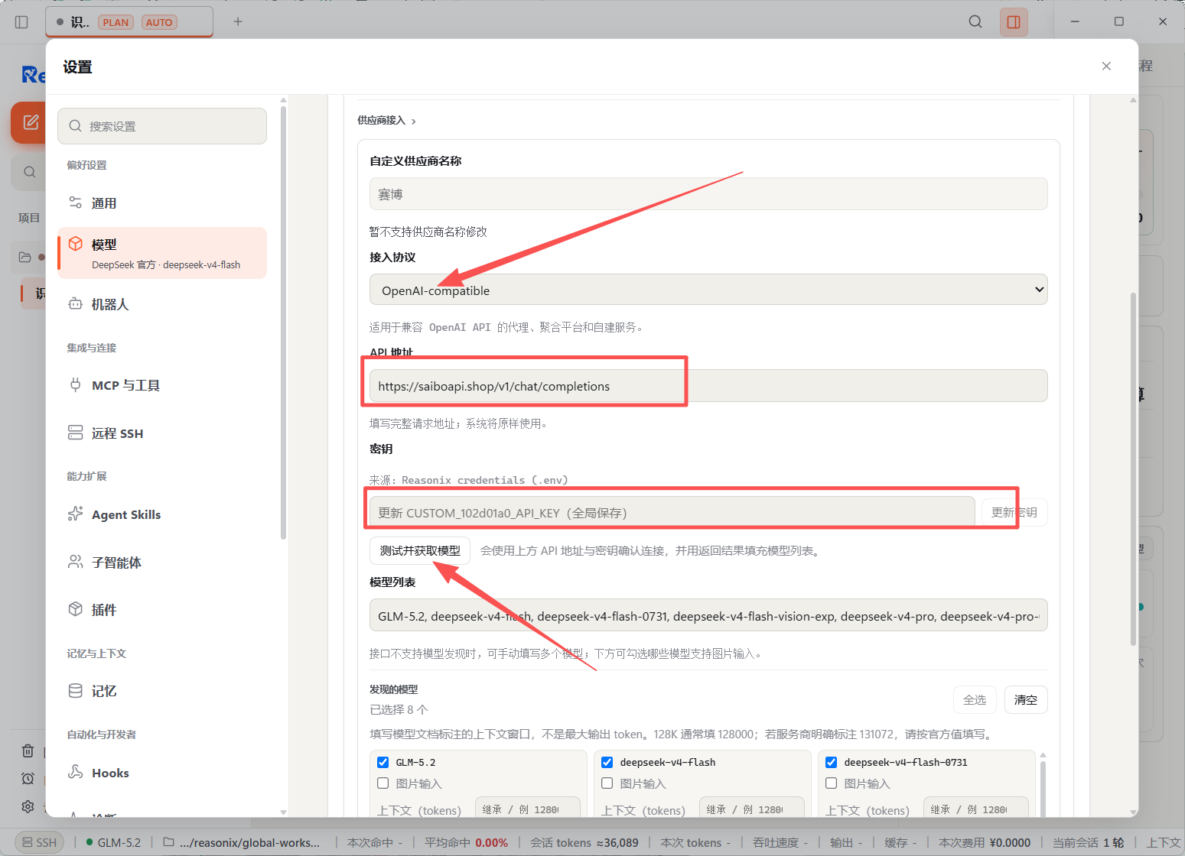
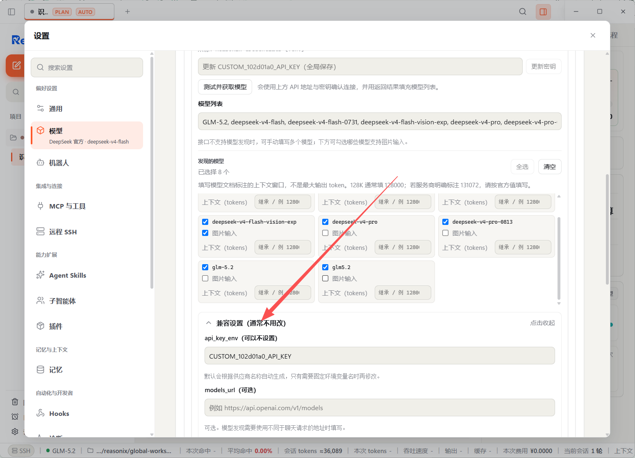
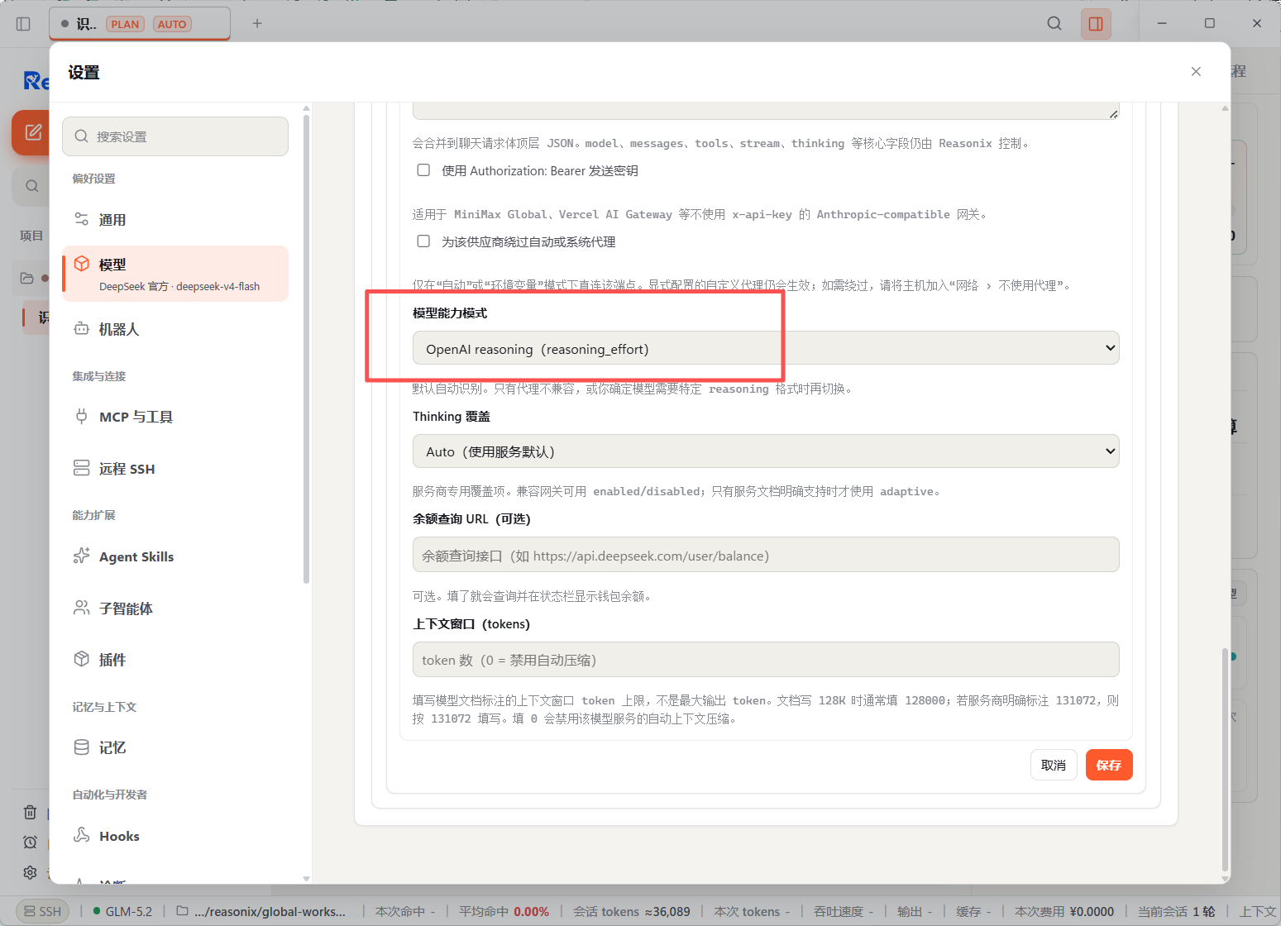

下面配置自定义模型推理强度：默认配置没办法设置自定义推理强度
%APPDATA%\reasonix
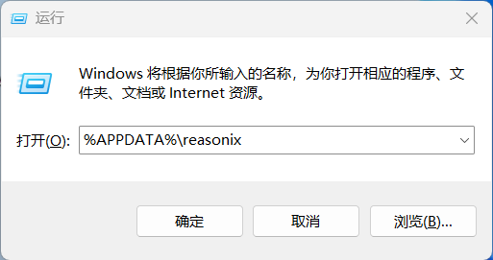
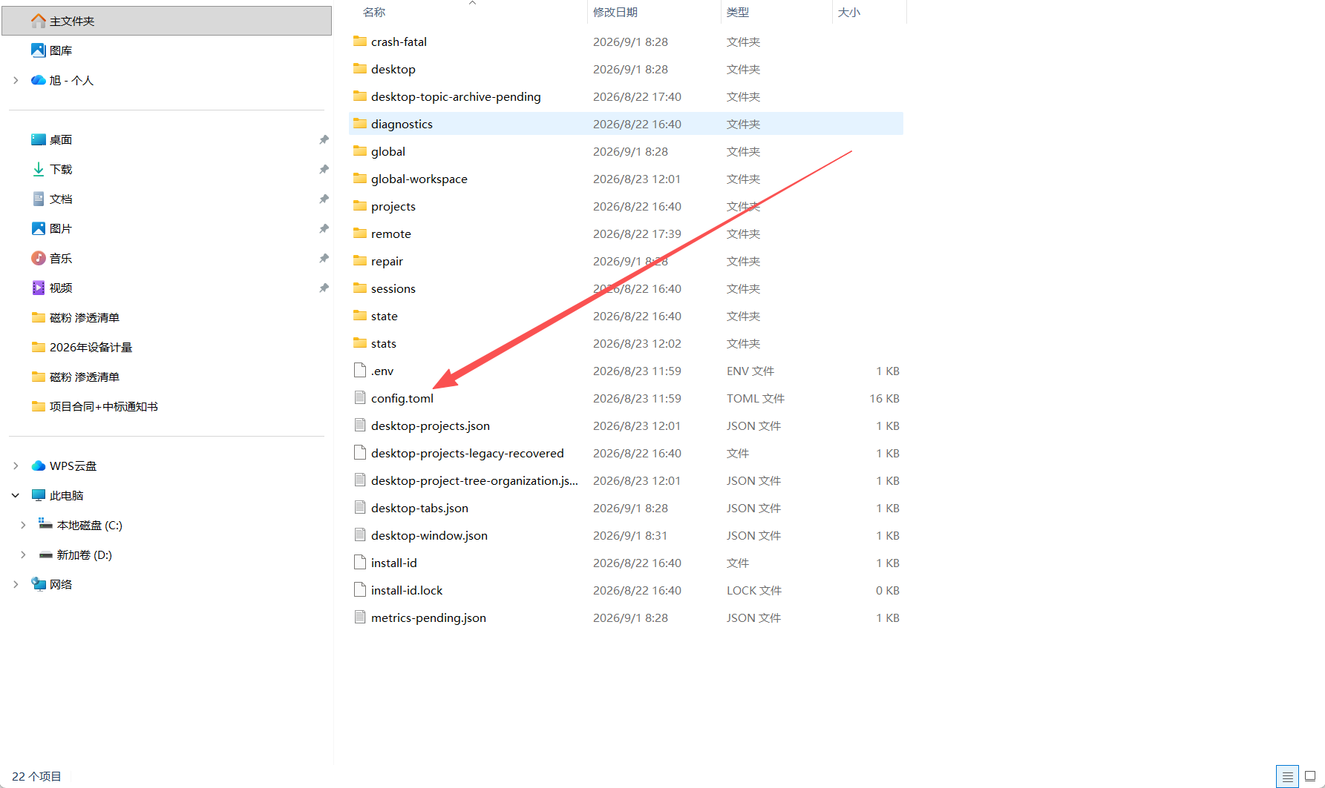
找到这个自定义模型下方加入两行代码重启软件即可
supported_efforts=["disabled","low","high","max"]#custom/effortlevelsexposedbythisprovider;overridesthebuilt-inKind/BaseURLdefault
default_effort="max"#usedwhen/effortisautoorunset;mustbeoneofsupported_efforts

